**Plan Revision Memo electronic submittal, sent by the Section Engineer.**

**You can use the sample email below to paste the text and cc list into your email (add any information listed in red).**

**From:** Your name will appear here automatically (Section Engineer)  
**Sent:** Date will appear automatically

**To:**  District Engineer   
**Cc:** Nicholson, Kent; Nelson, James S; Musgrove, Wes; Assistant District Engineer, Resident Construction Engineer

**Subject:** Insert Phase Number – Plan Revision, Bid Letting date: (XXXXX)

Plan Revision

        Primary County:

        Phase Number:

        Project Code:

This memo is to inform you of an upcoming plan revision for this project. The revision will involve ______.

If you have any questions or comments feel free to email me.

**District Engineer**:

District 1 - Smyth, Allison;

District 2 - Humpal, Nickolas;

District 3 - Felix, Jessica;

District 4 - Schram, Scott;

District 5 - Younie, Bob;

District 6 - Schnoebelen, Jim;

**Assistant District Engineer**:

District 1 - Vortherms, Jeremy;

District 2 - Kelly, Mary

District 3 - Tymkowicz, Shane;

District 4 - Mayberry, Wes;

District 5 - McElmeel, Steven;

District 6 - Tibodeau, Jesse

**Resident Construction Engineers**:

District 1 - Leong, Frank; Hoskins, Jenny; Skogerboe, Dustin;

District 2 - Howe, Kenneth; Loecher, Ron;

District 3 - Klemme, Jason; {Resident Construction Engineer};

District 4 - Dorsett, David; Smith, Brian;

District 5 - Finarty, Liz; VanBuskirk, Christy;

District 6 - Lamping, John; Simonson, Adrian; Holak, Hugh;

**District TSMO Engineers:**

Swisher, Andy;   District 1, District 2 (except Blackhawk Co.), and I-35 in District 5

Yates, Austin;   District 3 and District 4

Abuissa, Newman;   District 6, District 5 (except I-35), and Blackhawk Co. (District 2)

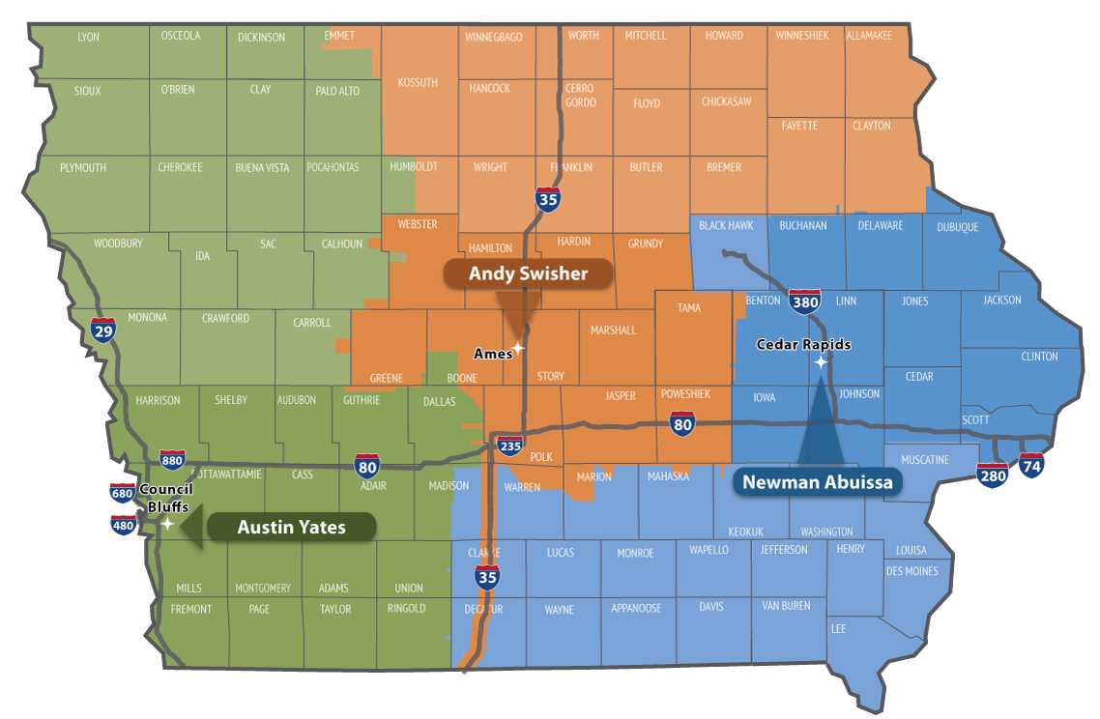

**Contact revision request:**

Email [DOT-Shell-Support](mailto:DOT-Shell-Support@iowadot.us?subject=Memo%20Shell%20Letter%20Contact%20revision%20request)

Subject: Memo Shell Letter Contact revision request

Copy and Paste into body of email

Please change the Shell Letter Contact *[Contacts name and email]*.

They were in this position *[Title ; position ; District ; Bureau].*

They reported to *[Contacts name and email].*

*[Contacts name and email]* is the New *[Title ; position ; District ; Bureau]*.

This change needs to be done on *[ALL Shell Letters; Indicate Shell Letter(s) if different then email subject].*

Thank you

**Revision request:**

Email [DOT-Shell-Support](mailto:DOT-Shell-Support@iowadot.us?subject=Memo%20Shell%20Letter%20revision%20request)

Subject: Memo Shell Letter revision request

Copy and Paste into body of email

Please find the attached Markup with the requested change. [Screen image of change, or marked up document]

This change needs to be done on *[ALL Shell Letters; Indicate Shell Letter(s) if different then email subject].*

Thank you