# IOWA DEPARTMENT OF TRANSPORTATION

**TO OFFICE:** Federal Highway Administration **DATE:** November 14, 2024

**ATTENTION:** Timothy Marshal **REF. NO.:** PrimaryCounty Name

Phase Number

**FROM:** Project Code:

**OFFICE:**

**SUBJECT:** Plan Revision

This project involves …

The project letting was on

This revision involves …

We request Federal Highway Administration approval and participation for this revision.

Attach.

cc: Kent Nicholson, Assistant Design Engineer

Wes Musgrove, Construction Engineer

District Engineer

Assistant District Engineer

**To**:

Marshall, Timothy

**cc**:

Nicholson, Kent; Musgrove, Wes;

**District Engineer**:

District 1 - Smyth, Allison;

District 2 - Humpal, Nickolas;

District 3 - Felix, Jessica;

District 4 - Schram, Scott;

District 5 - Younie, Bob;

District 6 - Schnoebelen, Jim;

**Assistant District Engineer**:

District 1 - Vortherms, Jeremy;

District 2 - Kelly, Mary

District 3 - Tymkowicz, Shane;

District 4 - Mayberry, Wes;

District 5 - McElmeel, Steven;

District 6 - Tibodeau, Jesse

**Resident Construction Engineers**:

District 1 - Leong, Frank; Hoskins, Jenny; Skogerboe, Dustin;

District 2 - Howe, Kenneth; Loecher, Ron;

District 3 - Klemme, Jason; {Resident Construction Engineer};

District 4 - Dorsett, David; Smith, Brian;

District 5 - Finarty, Liz; VanBuskirk, Christy;

District 6 - Lamping, John; Simonson, Adrian; Holak, Hugh;

**District TSMO Engineers:**

Swisher, Andy;   District 1, District 2 (except Blackhawk Co.), and I-35 in District 5

Yates, Austin;   District 3 and District 4

Abuissa, Newman;   District 6, District 5 (except I-35), and Blackhawk Co. (District 2)

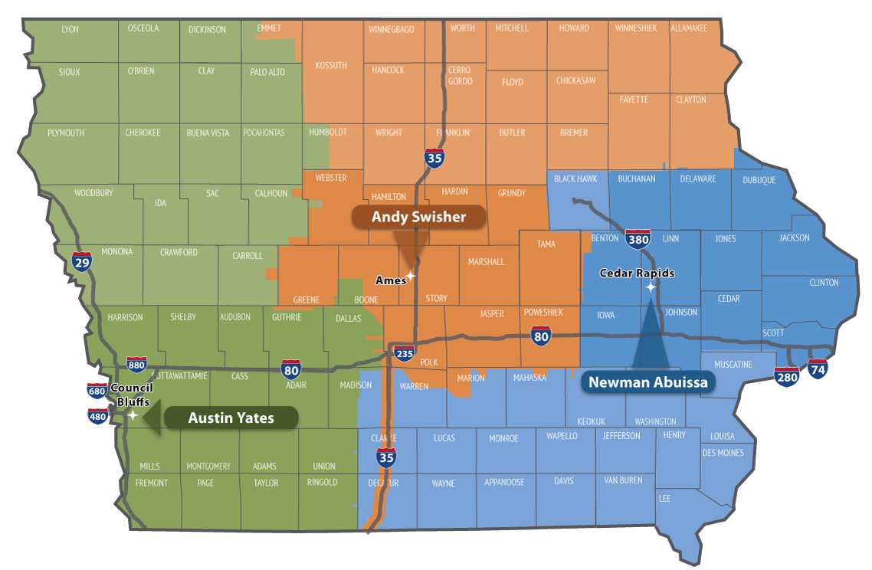

**Contact revision request:**

Email [DOT-Shell-Support](mailto:DOT-Shell-Support@iowadot.us?subject=FHWA_Letter%20Shell%20Letter%20Contact%20revision%20request)

Subject: FHWA_Letter Shell Letter Contact revision request

Copy and Paste into body of email

Please change the Shell Letter Contact *[Contacts name and email]*.

They were in this position *[Title ; position ; District ; Bureau].*

They reported to *[Contacts name and email].*

*[Contacts name and email]* is the New *[Title ; position ; District ; Bureau]*.

This change needs to be done on *[ALL Shell Letters; Indicate Shell Letter(s) if different then email subject].*

Thank you

**Revision request:**

Email [DOT-Shell-Support](mailto:DOT-Shell-Support@iowadot.us?subject=FHWA_Letter%20Shell%20Letter%20revision%20request)

Subject: FHWA_Letter Shell Letter revision request

Copy and Paste into body of email

Please find the attached Markup with the requested change. [Screen image of change, or marked up document]

This change needs to be done on *[ALL Shell Letters; Indicate Shell Letter(s) if different then email subject].*

Thank you