**Subject:** Primary County, Phase Number - DM5 Submittal, Bid Letting date: (XXXXX)

**DM5 - Design Methods Submittal:**

Primary County:

Project Code:

Phase Number:

Phase Location:

Work Code:

Project Directory Number:

**ADE/DCE/RCE:**

Please provide the following information to the **Design Team** within 2 weeks of this submittal**:**

**Yes No**

Construction Survey

Field Lab

Field Office

Materials to be salvaged on Tab. 110-13

If yes, select below and fill out contact name, phone# and salvage address:

Guardrail

Other. Please specify the items:

Contact name and phone#:

Address:

Traffic Control/Work Hour Restrictions

If yes, explain:

Special Events/Work Hours Restrictions

If yes, explain:

Project with detour:

If yes, who is responsible for furnishing, installing, maintaining and removing the detour:

Contractor

District will provide detour sheets.

DOT

Projects to be coordinated on Tab. 111-1

If yes, please provide project number(s) and type of work.

**DM5 Submittal Folder:** Place_Link_Here

**KMZ File**:  [Place](http://www.iowadot.gov/design/mkretlo/Local%20Settings/mkretlo/Projects/9106503004/Design/D3Submittal/D3sub%20Warren.PDF)_link_here

**Plan Review Meeting:**

**Yes No**

A plan review meeting will be scheduled to discuss the plans and/or comments with the District and RCE in approximately 1-2 weeks

*(For projects with over 50,000 CY of Contractor Furnished material (Embankment and/or Select material) include the following note with the email. In addition, see Design Manual 5B-3 for instructions on submitting plan sheets for review prior to final plan turn in.)*

***Place a copy of the DM5 plan set in the following location:***

This project requires over 50,000 CY of Contractor Furnished material. Plan sheets will be posted on the DOT website for review.

If you have any questions or comments, feel free to email me.

**To:** ADE, DCE, RCE (See names below and select appropriate RCE);

**Cc:**

{Assistant Design Engineer}; Brakke, Chris; {Assistant Design Engineer}; Nelson, James S; Nop, Michael; Poole, Chris; Hofer, Brad; Cagle, Gregory; Blue, Dana; Cook, Sarah; Stokes, Danny; Swenson, Mark A; Merryman, Kevin; Sprengeler, Dan; Beddow, Alan; Serio, Melissa; Poole, Angela; Bradley, Bryan; Dunn, Mark; Harris, Rachel; Pohlen, Nathan; Dell, Mark; Smith, Brian; Shell, Adam; Ta, Dung; Evans, David; {Final Design unit leader Unit 1}; Worrel, Brian; Gansen, Elijah; Brink, Kenneth; Zeimen, Danny; Wilkinson, Cedric; Serio, Melissa; Johnson, Brian;

**District 1:**

ADE/DCE: Vortherms, Jeremey; Nixon, Scott;

RCE: Leong, Frank; Hoskins, Jenny; Skogerboe, Dustin;

Smyth, Allison; Passick, Sean; Adey, Ben; Breitbach, Donna;

*Location and Environment (Cultural, T&E, Water)*

Becker, Janee; Garton, Jill;

Asberry, Claire; Boone, Greene

Carlson, Michael; Polk, Story, Webster

Beavers, Brandy; Jasper, Poweshiek

Sloppy, Mark; Marshall, Tama

Walls, Brandon; Grundy, Hamilton, Hardin

**District 2:**

ADE/DCE: Kelly, Mary; Gelhaus, Roy;

RCE: Loecher, Ron; Olsen, Andrew

Humpal, Nickolas; Erickson, Daryl; Ruter, Jason; Kubik, Tyler;

*Location and Environment (Cultural, T&E, Water)*

Bacon, Jeff; Struecker, Brock; Walls, Brandon;

**District 3:**

ADE/DCE: Tymkowicz, Shane; Klemme, Jason;

RCE:{Resident Construction Engineer}; {Resident Construction Engineer};

Felix, Jessica; Thayer, Michael; Huju, Todd; Justin Pottorff; Pryor, Dylan;

*Location and Environment (Cultural, T&E, Water)*

Becker, Janee; Duncan, Chelsea; Carlson, Michael; Sturtz, Samuel

**District 4:**

ADE/DCE: Mayberry, Wes; Redmond, Daniel;

RCE: Dorsett, David;

Schram, Scott; Epperson, Nathaniel;

Lechnowsky, Orest; Kohl, Jason; Harrison, Pottawattamie, Mills, Fremont, Page, Montgomery, & Shelby

Malone, Travis; Mocha, Nicholas; Audubon, Cass, Adams, Taylor, Guthrie, Adair, Union, Ringgold, Dallas, & Madison

*Location and Environment (Cultural, T&E, Water)*

Woodcock, Jacob; Duncan, Chelsea; Asberry, Claire;

**District 5:**

ADE/DCE: McElmeel, Steven; Bielser, Darrick;

RCE: Finarty, Liz; Vanbuskirk, Christy

Younie, Bob; Claeys, Mark; Clancy, Bonnie;

*Location and Environment (Cultural, T&E, Water)*

Woodcock, Jacob; Garton, Jill; Beavers, Brandy;

**District 6:**

ADE/DCE: Tibodeau, Jesse; Alvarez, Danielle;

RCE: Holak, Hugh; Lamping, John; Simonson, Adrian;

Schnoebelen, Jim; Morrell, George;

Abu Afifeh, Ahmad; Clinton and Scott counties, I-74 Project

Harle, Mark; Benton, Cedar, Iowa, and Johnson counties

Storey, Thomas; Linn County, Pavement Preservation Program

Bardgett, Anthony; Buchanan, Delaware, Dubuque, Jackson, and Jones counties

*Location and Environment (Cultural, T&E, Water)*

Bacon, Jeff; Struecker, Brock; Sloppy, Mark;

**For Interstate Projects:**

Program.Delivery-IA@dot.gov

**For Projects that require over 50,000 CY of Contractor Furnished material:**

DOT-Shell-Support@iowadot.us

**District TSMO Engineers:**

Swisher, Andy; District 1, District 2 (except Blackhawk Co.), and I-35 in District 5

Yates, Austin; District 3 and District 4

Abuissa, Newman; District 6, District 5 (except I-35), and Blackhawk Co. (District 2)

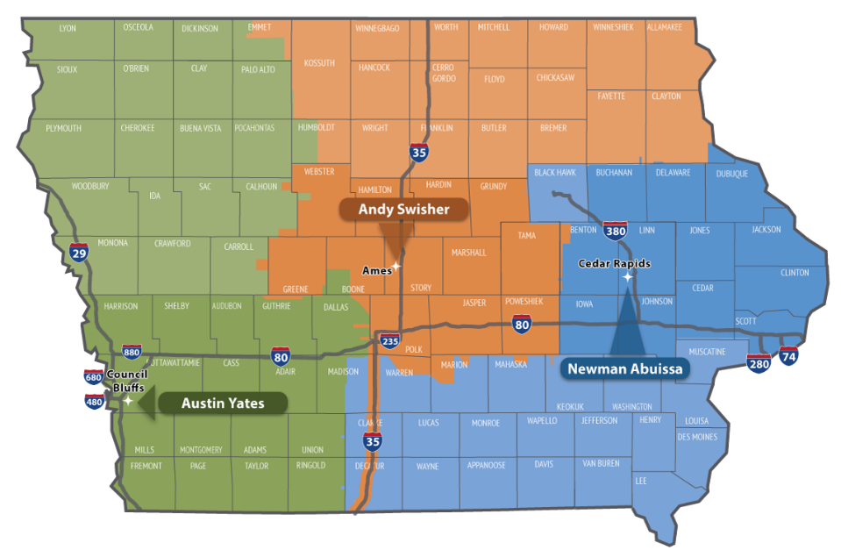

**Contact revision request:**

Email [DOT-Shell-Support](mailto:DOT-Shell-Support@iowadot.us?subject=DM5%20Shell%20Letter%20Contact%20revision%20request%20)

Subject: DM5 Shell Letter Contact revision request

Copy and Paste into body of email

Please change the Shell Letter Contact *[Contacts name and email]*.

They were in this position *[Title ; position ; District ; Bureau].*

They reported to *[Contacts name and email].*

*[Contacts name and email]* is the New *[Title ; position ; District ; Bureau]*.

This change needs to be done on *[ALL Shell Letters; Indicate Shell Letter(s) if different then email subject].*

Thank you

**Revision request:**

Email [DOT-Shell-Support](mailto:DOT-Shell-Support@iowadot.us?subject=D5%20Shell%20Letter%20revision%20request%20)

Subject: DM5 Shell Letter revision request

Copy and Paste into body of email

Please find the attached Markup with the requested change. [Screen image of change, or marked up document]

This change needs to be done on *[ALL Shell Letters; Indicate Shell Letter(s) if different then email subject].*

Thank you