**Subject:** Primary County, Phase number - D3 Submittal

**D3 - Preliminary Bridge Submittal:**

Primary County:

Project Code:

Phase Number:

Phase Location:

Work Code:

Project Directory Number:

**D3 Submittal Folder:**  [Place](http://www.iowadot.gov/design/mkretlo/Local%20Settings/mkretlo/Projects/9106503004/Design/D3Submittal/D3sub%20Warren.PDF) link of folder here

**Project Documentation File**:  [Place](http://www.iowadot.gov/design/mkretlo/Local%20Settings/mkretlo/Projects/9106503004/Design/D3Submittal/D3sub%20Warren.PDF)_link_here

**KMZ File**:  [Place](http://www.iowadot.gov/design/mkretlo/Local%20Settings/mkretlo/Projects/9106503004/Design/D3Submittal/D3sub%20Warren.PDF)_link_here

**D3 Checklist**

*Add information to address any incomplete items below:*

**Yes N/A No**

Updated typicals for correct dimensions and stationing

Updated horizontal and vertical alignments

Ditch grades and ditch bar graph complete

Entrances and crossovers (future labeled as future)

Auxiliary and turn lanes including tapers shown

Final interchange layouts and details

Staging or detour runarounds shown

Completed cross sections of mainline

Completed cross sections of side roads

Completed cross sections of accessways

Completed cross sections of ramps and loops

Cross section with estimate of stability berm and backslope benching locations

Cross section of auxiliary and turn lanes including tapers

Cross section of side road returns

If you have any questions or comments, feel free to email me.

**To:**

Meyer, Ronald;

**Cc:**

Nicholson, Kent; Nicholson, Kent; Nelson, James S; Nop, Michael; Ellis, Jimmy; Poole, Chris; Wright, Eric; Hofer, Brad; Stokes, Danny; Swenson, Mark A; Johnson, Katherine; Cuva, Nicole; Cagle, Gregory; Blue, Dana; Cook, Sarah; Dell, Mark; Bradley, Bryan; Smith, Brian; Ta, Dung; Harris, Rachel; Pohlen, Nathan; Brink, Kenneth; Poole, Angela;

**District 1:**

Smyth, Allison; Vortherms, Jeremey; Passick, Sean; Adey, Ben; Breitbach, Donna;

*Location and Environment (Cultural, T&E, Water):*

Becker, Janee; Garton, Jill;

Asberry, Claire; Boone, Greene

Carlson, Michael; Polk, Story, Webster

Beavers, Brandy; Jasper, Poweshiek

Sloppy, Mark; Marshall, Tama

Walls, Brandon; Grundy, Hamilton, Hardin

*NEPA contacts:*

Newell, DeeAnn; Walter, Blake;

**District 2:**

Humpal, Nickolas; Kelly, Mary; Erickson, Daryl; Siems, Kim;

*Location and Environment (Cultural, T&E, Water):*

Bacon, Jeff; Struecker, Brock; Walls, Brandon;

*NEPA contacts:*

Newell, DeeAnn; Walter, Blake;

**District 3:**

Felix, Jessica; Tymkowicz, Shane; Thayer, Michael; Huju, Todd; Justin, Pottorff;

*Location and Environment (Cultural, T&E, Water):*

Becker, Janee; Duncan, Chelsea; Carlson, Michael; Sturtz, Samuel

*NEPA contacts:*

Newell, DeeAnn; Schwienebart, Chris;

**District 4:**

Schram, Scott; Mayberry, Wes; Epperson, Nathaniel;

Lechnowsky, Orest; Kohl, Jason; Harrison, Pottawattamie, Mills, Fremont, Page, Montgomery, & Shelby

Malone, Travis; Mocha, Nicholas; Audubon, Cass, Adams, Taylor, Guthrie, Adair, Union, Ringgold, Dallas, & Madison

Cihacek, Joseph; Harrison, Pottawattamie, Mills, Fremont, Page, Montgomery, & Shelby

Todd, Frank; Audubon, Cass, Adams, Taylor, Guthrie, Adair, Union, Ringgold, Dallas, & Madison

*Location and Environment (Cultural, T&E, Water):*

Woodcock, Jacob; Duncan, Chelsea; Asberry, Claire;

*NEPA contacts:*

Newell, DeeAnn; Schwienebart, Chris;

**District 5:**

Younie, Bob; McElmeel, Steven; Clancy, Bonnie; Claeys, Mark;

Location and Environment (Cultural, T&E, Water):

Woodcock, Jacob; Beavers, Brandy; Garton, Jill;

*NEPA contacts:*

Newell, DeeAnn; Leanos, Pedro;

**District 6:**

Schnoebelen, Jim; Tibodeau, Jesse; Morrell, George;

Abu Afifeh, Ahmad; Clinton and Scott counties, I-74 Project

Harle, Mark; Benton, Cedar, Iowa, and Johnson counties

Storey, Thomas; Linn County, Pavement Preservation Program

Bardgett, Anthony; Buchanan, Delaware, Dubuque, Jackson, and Jones counties

*Location and Environment (Cultural, T&E, Water):*

Bacon, Jeff; Struecker, Brock; Sloppy, Mark;

*NEPA contacts:*

Newell, DeeAnn; Schwake, Christine;

**Major Alignment, Intersection and/or Interchange Work**

If major alignment changes are made at any point (such as bypasses, new interchanges, or significant changes, not just a 4-foot adjustment, etc.),

Bernhard, Charles;

**District TSMO Engineers:**

Swisher, Andy; District 1, District 2 (except Blackhawk Co.), and I-35 in District 5

Yates, Austin; District 3 and District 4

Abuissa, Newman; District 6, District 5 (except I-35), and Blackhawk Co. (District 2)

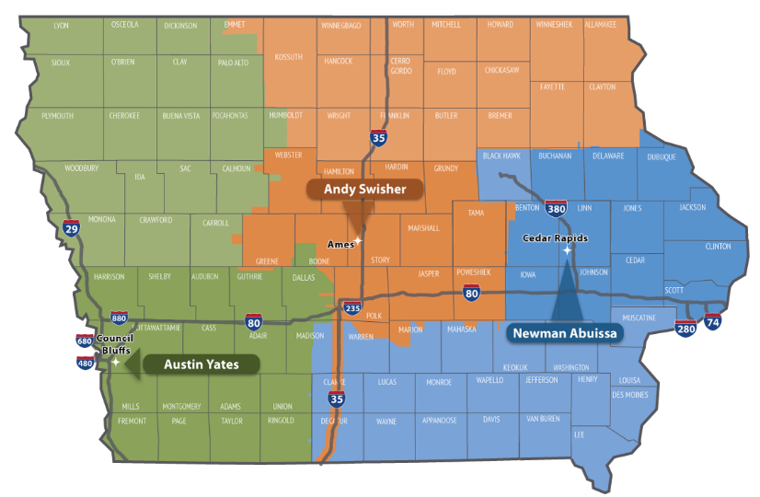

**Contact revision request:**

Email, [DOT-Shell-Support](mailto:DOT-Shell-Support@iowadot.us?subject=D3%20Shell%20Letter%20Contact%20revision%20request)

Subject: D3 Shell Letter Contact revision request

Copy and Paste into body of email

Please change the Shell Letter Contact *[Contacts name and email]*.

They were in this position *[Title ; position ; District ; Bureau].*

They reported to *[Contacts name and email].*

*[Contacts name and email]* is the New *[Title ; position ; District ; Bureau]*.

This change needs to be done on *[ALL Shell Letters; Indicate Shell Letter(s) if different then email subject].*

Thank you

**Revision request:**

Email, [DOT-Shell-Support](mailto:DOT-Shell-Support@iowadot.us?subject=D3%20Shell%20Letter%20revision%20request)

Subject: D3 Shell Letter revision request

Copy and Paste into body of email

Please find the attached Markup with the requested change. [Screen image of change, or marked up document]

This change needs to be done on *[ALL Shell Letters; Indicate Shell Letter(s) if different then email subject].*

Thank you