**IOWA DEPARTMENT OF TRANSPORTATION**

**TO OFFICE:** District ____ **DATE:** _______________

**ATTENTION:** District Engineer **REF.:** _________ County

Phase #: _____________

**FROM:** Alice Welch *or* Jeremy HarrisProject Code: _________

SAP No.: ____________

**OFFICE:** Design

**SUBJECT:** Survey Completion (D1)

The topographic engineering survey has been collected and the D1 date cleared for the proposed project for the _______________*description from MasterWorks*______________.

The field survey work was completed on _______ by (*choose one*) the Survey Section of the Office of Design, District # or Consultant name and contract No. The SUR file is located ____________.

The photogrammetry was completed from aerial photography collected on _______ by (*choose one*) the Photogrammetry Section of the Office of Design or Consultant Name and Contract No.) The PHO, RAS and TIN files are located ______________________.

___:mk

Cc: Design Project Engineer Assistant District Engr. District Utility Coordinator

District Land Surveyor {Assistant Design Director} K. D. Nicholson

N. Cuva M. Dell E. C. Wright

{Assistant Design Director } B. Bradley B. Hofer

C. Poole W. A. Sorenson M. A. Swenson

D. Stokes J. S. Nelson D. A. Popp

M. Nop J. Ellis B. Smith

A. Poole B. Hucker R. Meyer

K. Brink A. Woods (RR) D. Philips (RR)

**District Engineer**:

District 1 - Smyth, Allison;

District 2 - Humpal, Nickolas;

District 3 - Felix, Jessica;

District 4 - Schram, Scott;

District 5 - Younie, Bob;

District 6 - Schnoebelen, Jim;

**cc**:

Nickolson, Kent; Wright, Eric; Hofer, Brad; Sorenson, Willy; Nelson, James S; Ellis, Jimmy; Poole, Angela; Cuva, Nicole; Nicholson, Kent; Swenson, Mark A; Popp, Deanne; Smith, Brian; Hucker, Ben; {Assistant Design Director}; Dell, Mark; Bradley, Bryan; Poole, Chris; Stokes, Danny; Nop, Michael; Meyer, Ronald; Brink,Kenneth;

**Assistant District Engineer**:

District 1 - Vortherms, Jeremy;

District 2 - Kelly, Mary;

District 3 - Tymkowicz, Shane;

District 4 - Mayberry, Wes;

District 5 - McElmeel, Steven;

District 6 - Tibodeau, Jesse;

**District Land Surveyor**:

District 1 - Hildreth, Anthony;

District 2 - Eilders, Miranda;

District 3 - Sailer, James;

District 4 - Fox, Bill;

District 5 - Steffensmeier, Craig;

District 6 - Burger, Brad;

**District Utility Coordinator**:

District 1 - Passick, Sean;

District 2 - Erickson, Daryl;

District 3 - Thayer, Michael;

District 4 - Epperson, Nathaniel;

District 5 - Clancy, Bonnie;

District 6 - Morrell, George;

**Design Project Engineer**:

Road 1 - Holst, Jason;

Road 2 - Jia, Yanxiao;

Road 3 - Flattery, Paul;

**RR Involvement**:

Woods, Amanda; Philips,David;

**District TSMO Engineers:**

Swisher, Andy;   District 1, District 2 (except Blackhawk Co.), and I-35 in District 5

Yates, Austin;   District 3 and District 4

Abuissa, Newman;   District 6, District 5 (except I-35), and Blackhawk Co. (District 2)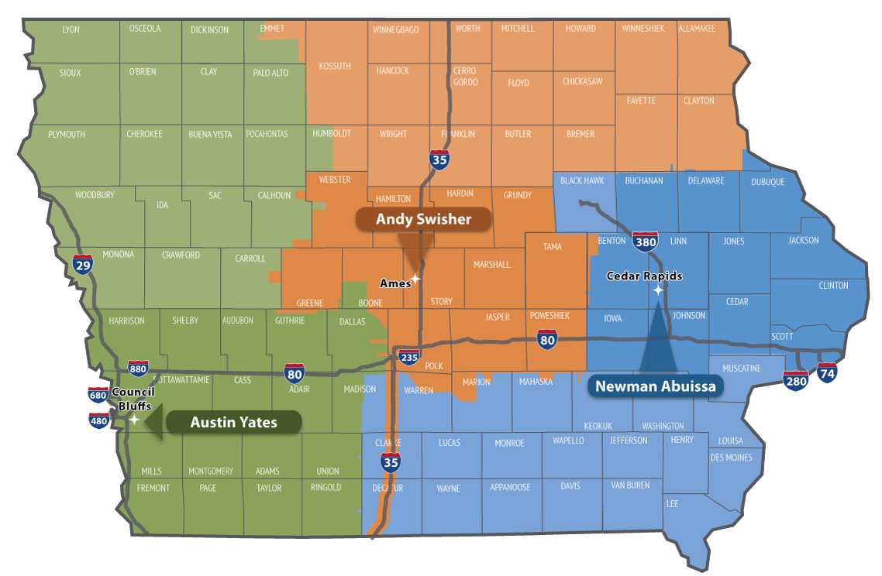

**Contact revision request:**

Email [DOT-Shell-Support](mailto:DOT-Shell-Support@iowadot.us?subject=D1%20Shell%20Letter%20Contact%20revision%20request)

Subject: D1 Shell Letter Contact revision request

Copy and Paste into body of email

Please change the Shell Letter Contact *[Contacts name and email]*.

They were in this position *[Title ; position ; District ; Bureau].*

They reported to *[Contacts name and email].*

*[Contacts name and email]* is the New *[Title ; position ; District ; Bureau]*.

This change needs to be done on *[ALL Shell Letters; Indicate Shell Letter(s) if different then email subject].*

Thank you

**Revision request:**

Email [DOT-Shell-Support](mailto:DOT-Shell-Support@iowadot.us?subject=D1%20Shell%20Letter%20revision%20request)

Subject: D1 Shell Letter revision request

Copy and Paste into body of email

Please find the attached Markup with the requested change. [Screen image of change, or marked up document]

This change needs to be done on *[ALL Shell Letters; Indicate Shell Letter(s) if different then email subject].*

Thank you