Field Welding Steel Pile
(www.iowadot.gov/construction/field_welding_steel_pile1.doc)

Instructional Memorandum (IM) 558 - Structural Field Welding and Inspection is the contract document that the inspector should become familiar with. The first two articles of Section X and all of Sections XI and XV are essential for the inspector. Section XV should also be reviewed by the welder.

All welding must be done by a state-certified welder. The qualification test is not specific for welding steel piling and the type of weld used for the test is not the same type that is required for splicing piling. A certified welder may not be aware of how piling are to be welded.

IM 560 – Qualification Tests for Field Welding explains the qualification test for the welder and the classification system used to identify which types and positions of welding the welder is qualified to perform.

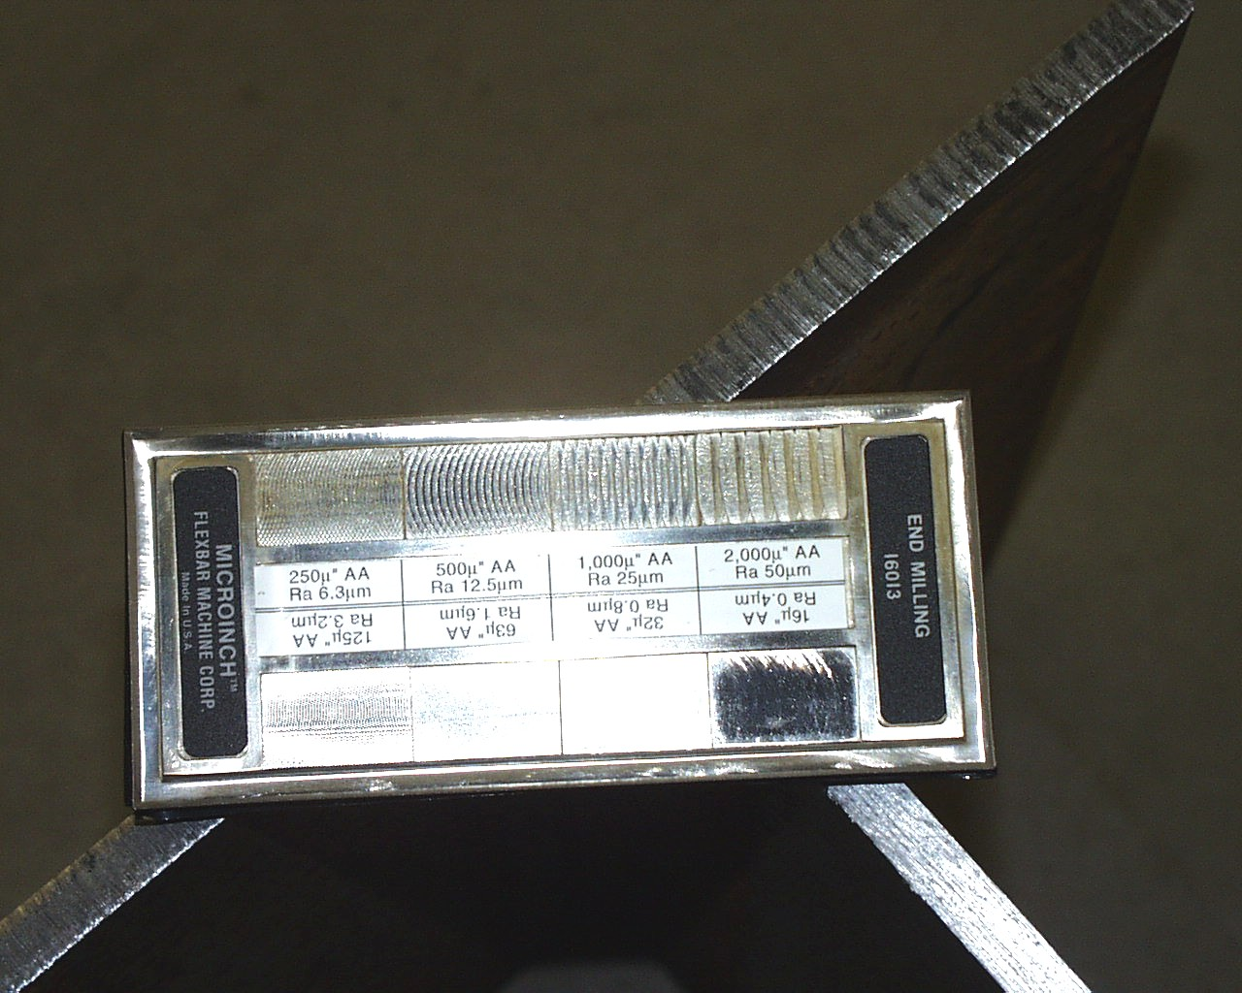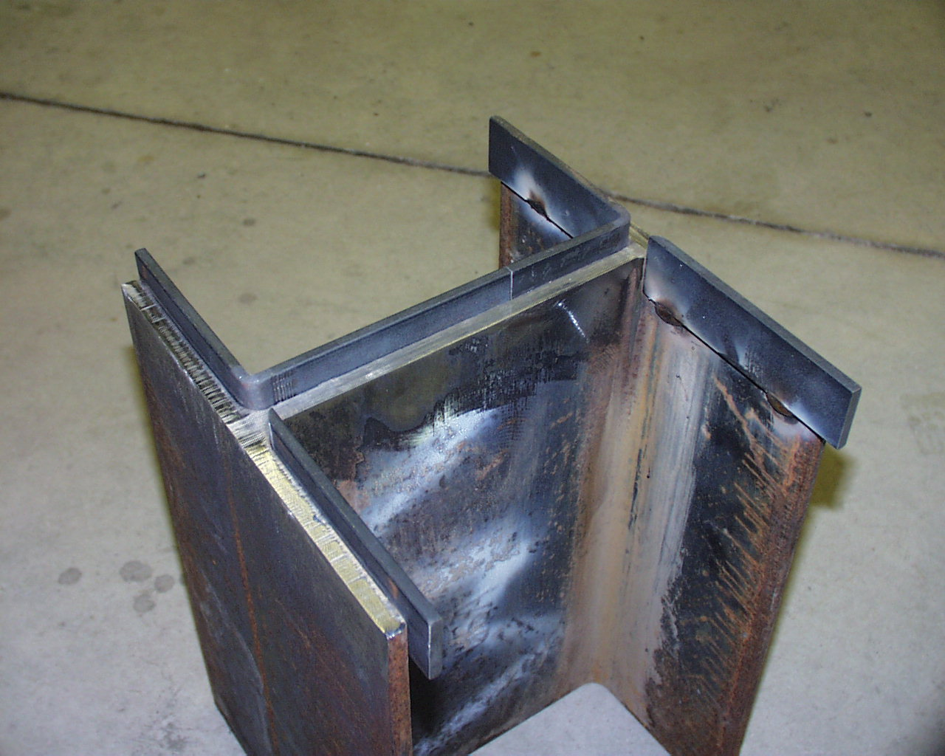
Picture 1 Picture 2

The top of the pile to be extended shall be square and all surfaces to be welded shall be cleaned with a grinder or wire brush and shall be dry and free of scale, slag, rust, moisture, grease and any other foreign material that would prevent proper welding. The surfaces to be welded shall also have a roughness of 1,000 micro-inches or less as compared to a surface roughness gauge. (pic. 1)

The backing plates may be tack welded in place if they are 1/4” to 3/8” thick. They shall be bent or ground to fit snug against the web and flanges. (pic. 2)

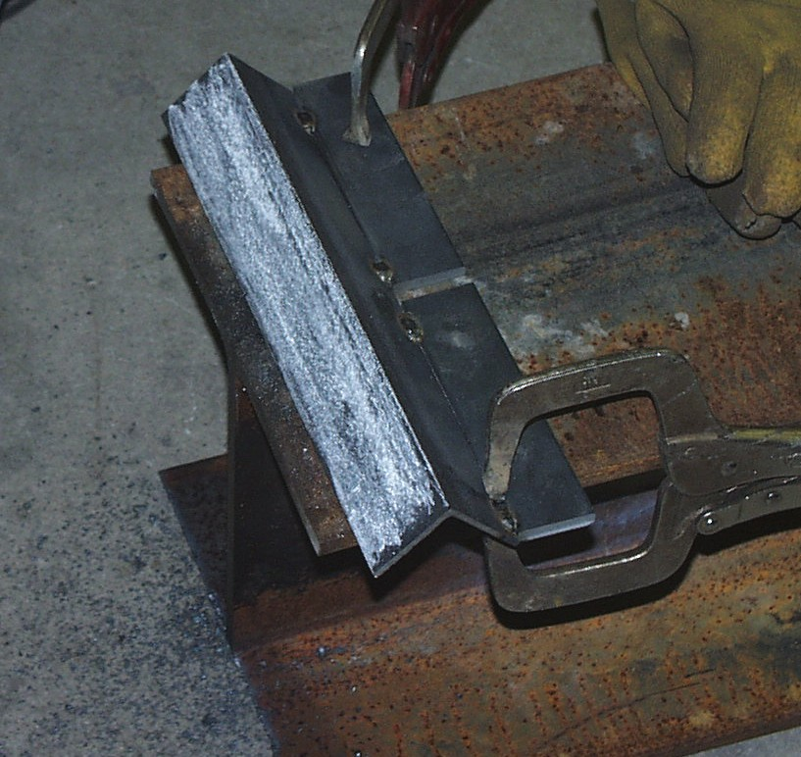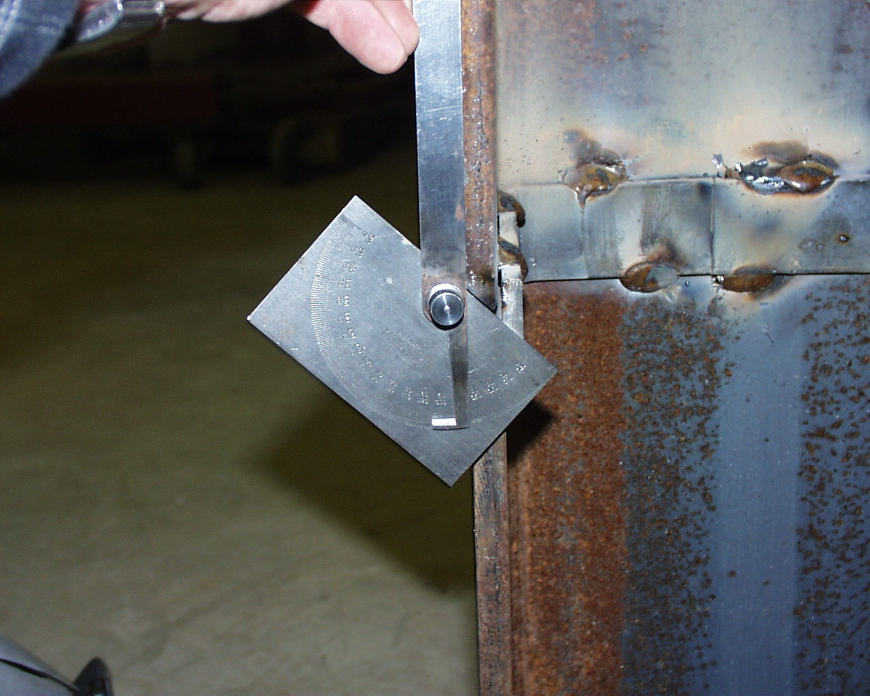
Picture 3 Picture 4

The bottom of the pile extension shall be beveled 45˚ on the outside of both flanges and on one side of the web. Clamping a piece of angle iron to the pile is one way of creating a guide to run the cutting torch along to help create the correct angle. If the contractor does a good job of cutting the bevel, minimal grinding will be required to meet the angle and roughness criteria. (pic. 3)

An angle measurement gauge can be used to determine if the bevel is within the ± 5˚ tolerance. (pic. 4)

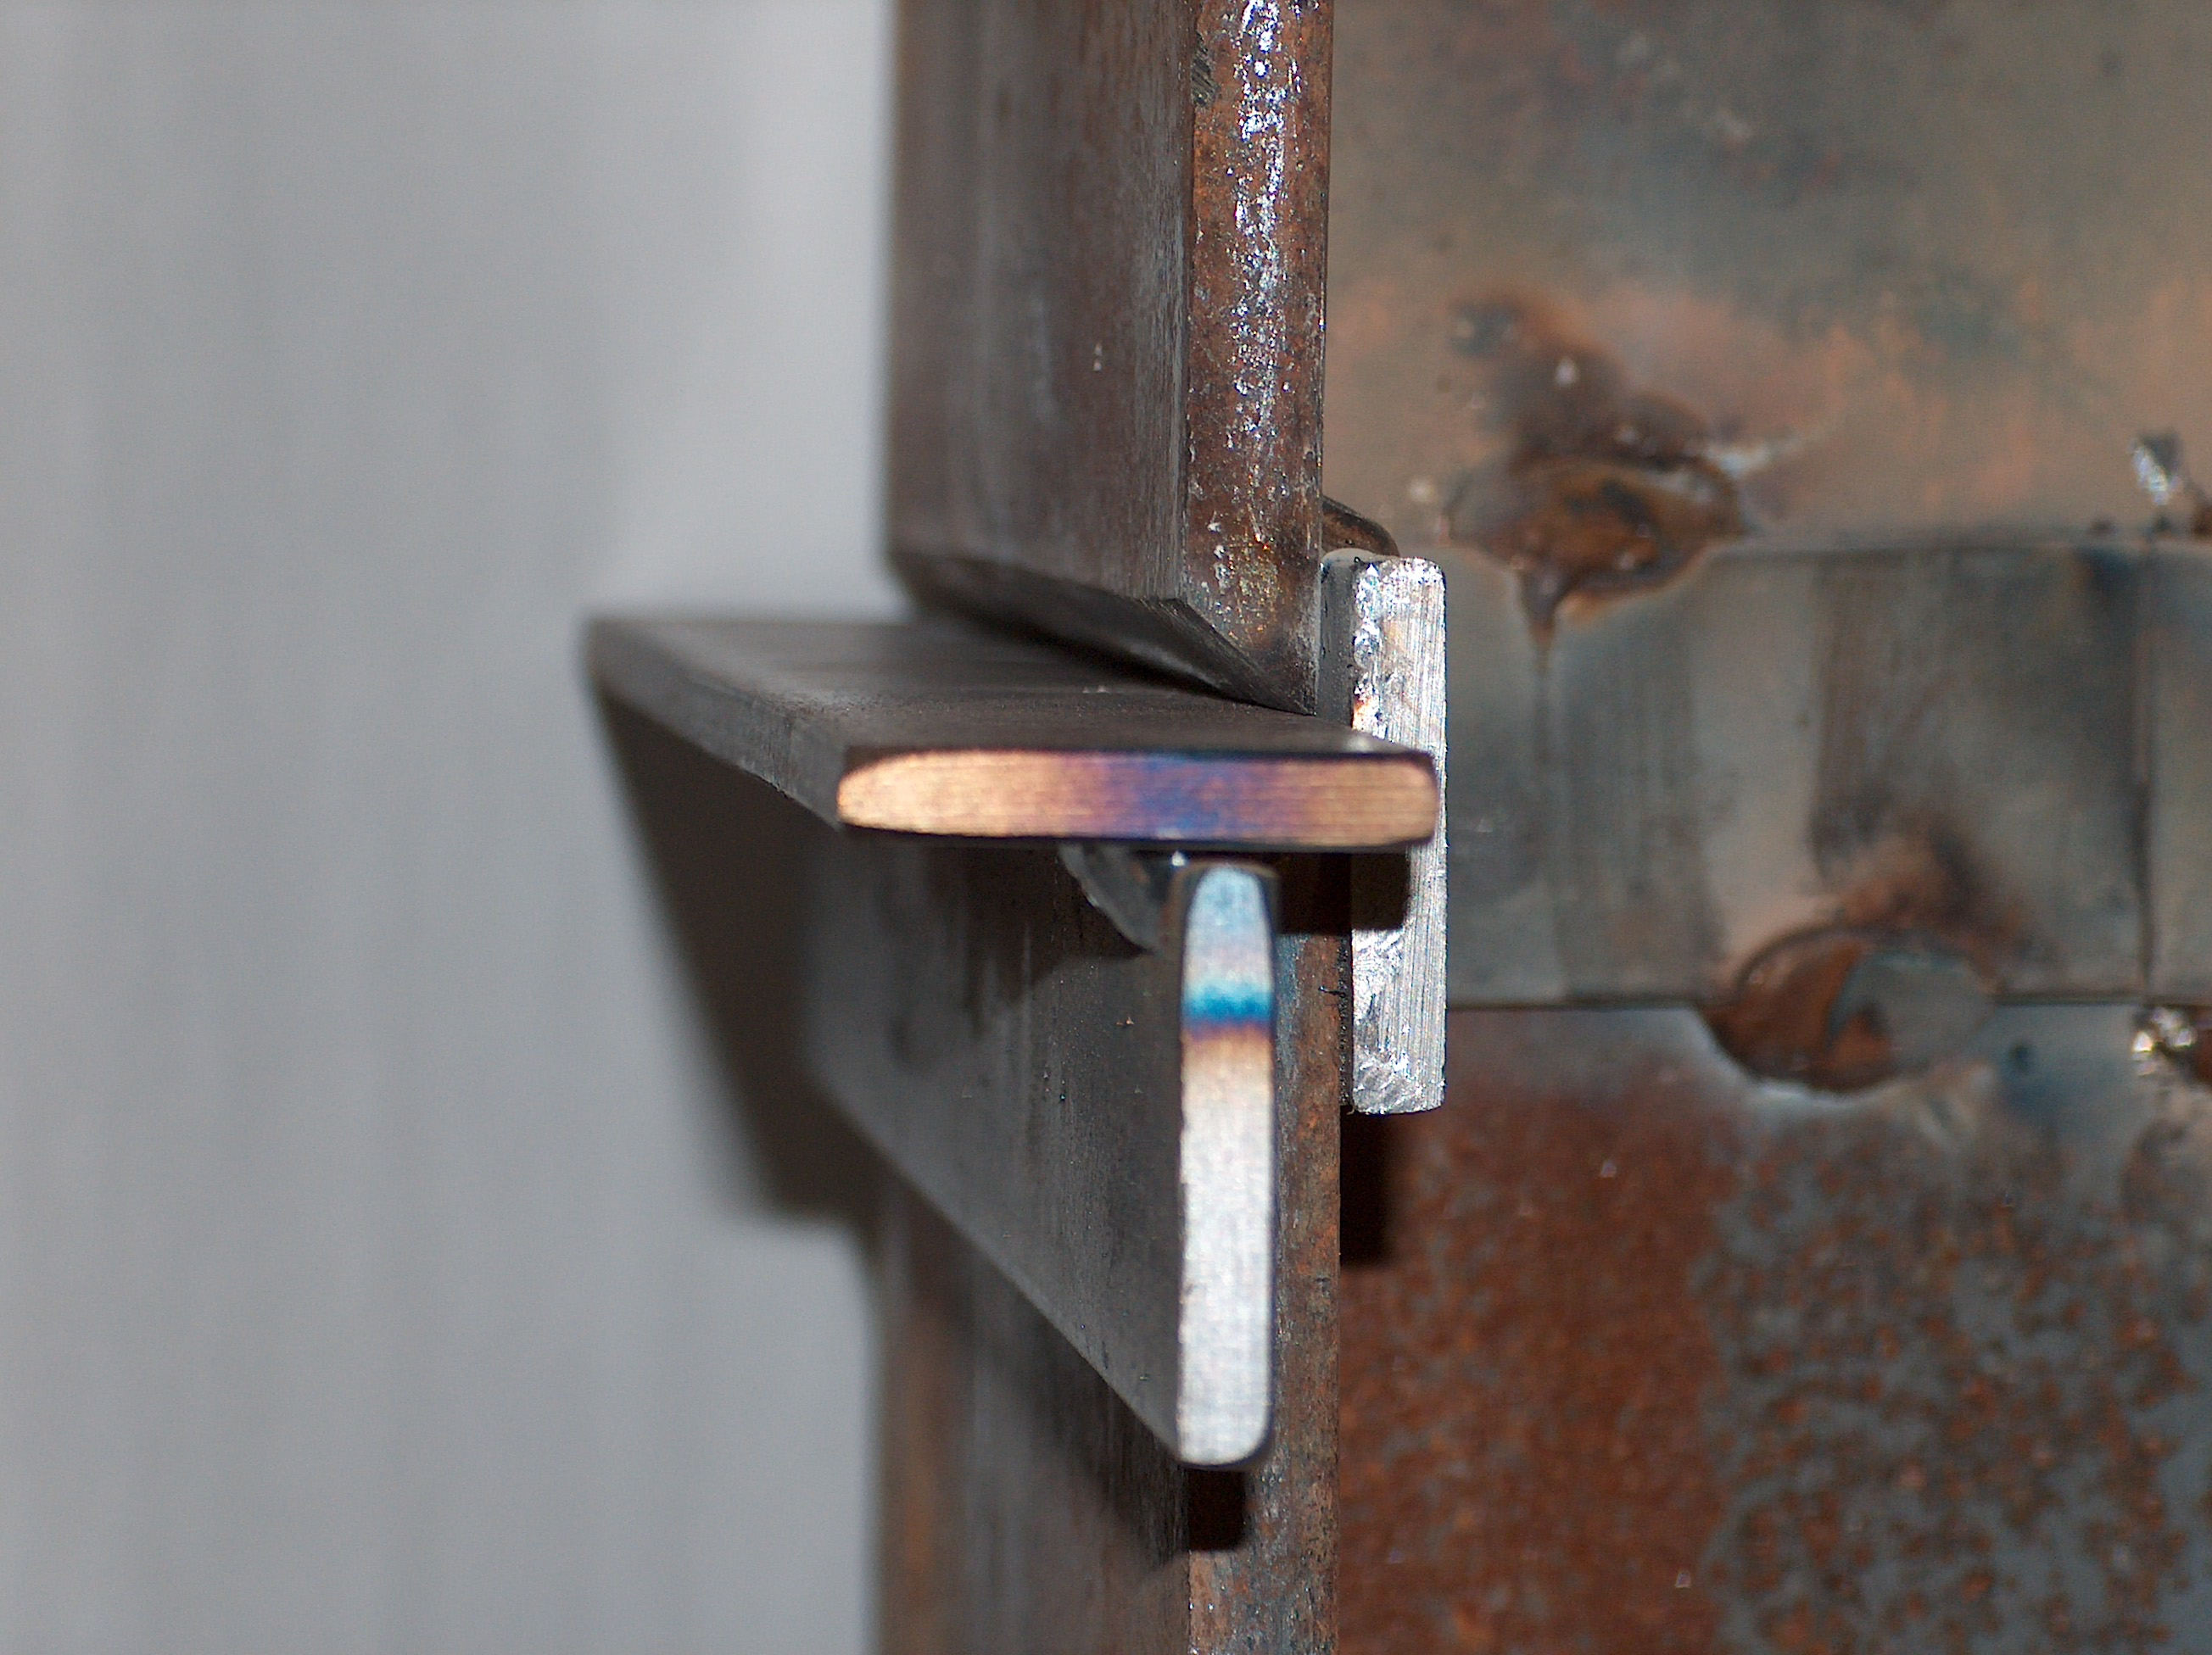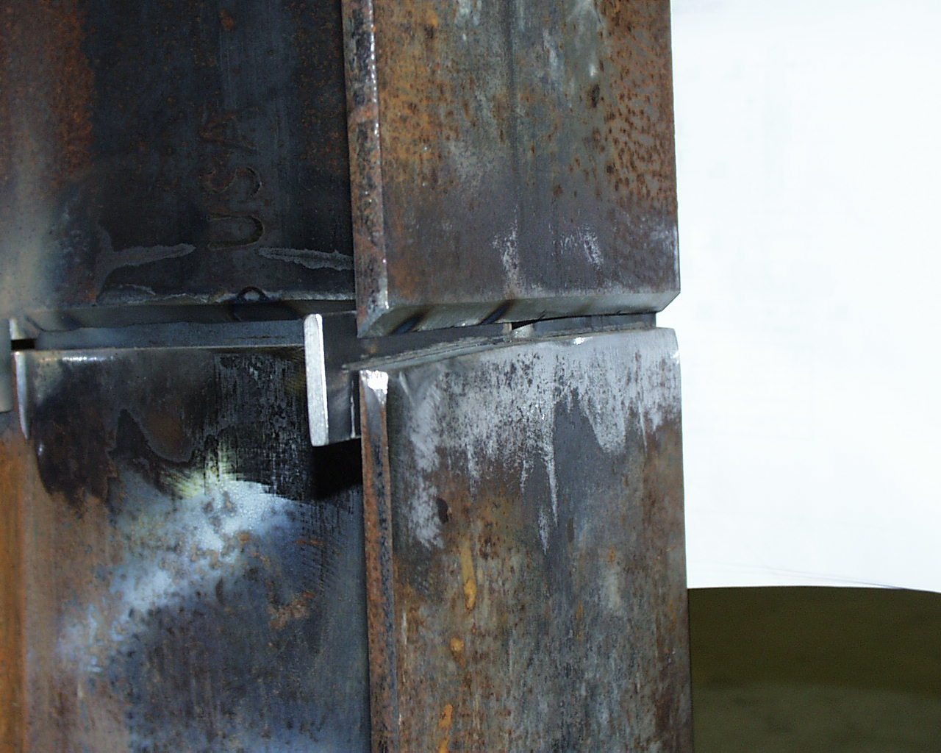
Picture 5 Picture 6

A 1/4 inch space (root opening) is required between the two sections of piling before welding them together. Picture 5 shows a 1/4 inch thick spacer being used to create the root opening within the given tolerances. The contractor can then tack weld the pile extension to the backer plates to hold it in position and then remove the spacer as shown in picture 6.

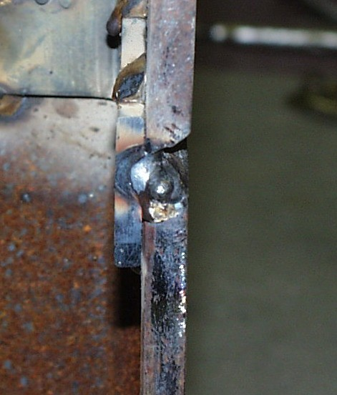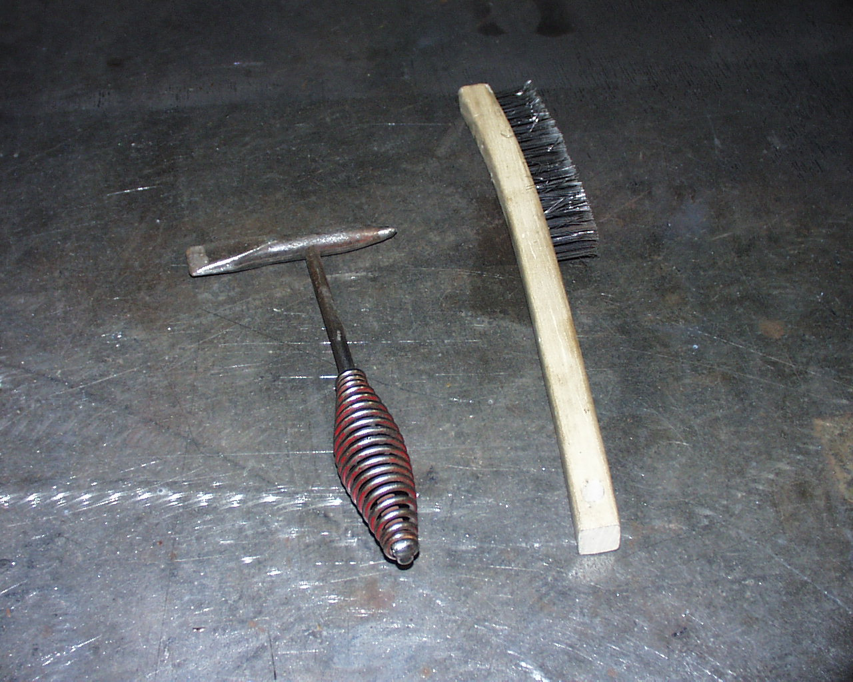
Picture 7 Picture 8

The root opening allows the welding electrode to arc against the backer plate and burn into it creating a full penetration weld. (pic. 7) If the root opening is not large enough, the welding electrode will arc before it reaches the backer plate and a full penetration weld will not be achieved.

Slag shall be removed with a chipping hammer and wire brush after each weld pass. (pic. 8)

A preheat temperature of 50˚ F is required before most metal piling are welded. Welding is not allowed when the ambient air temperature is below 0˚ F.

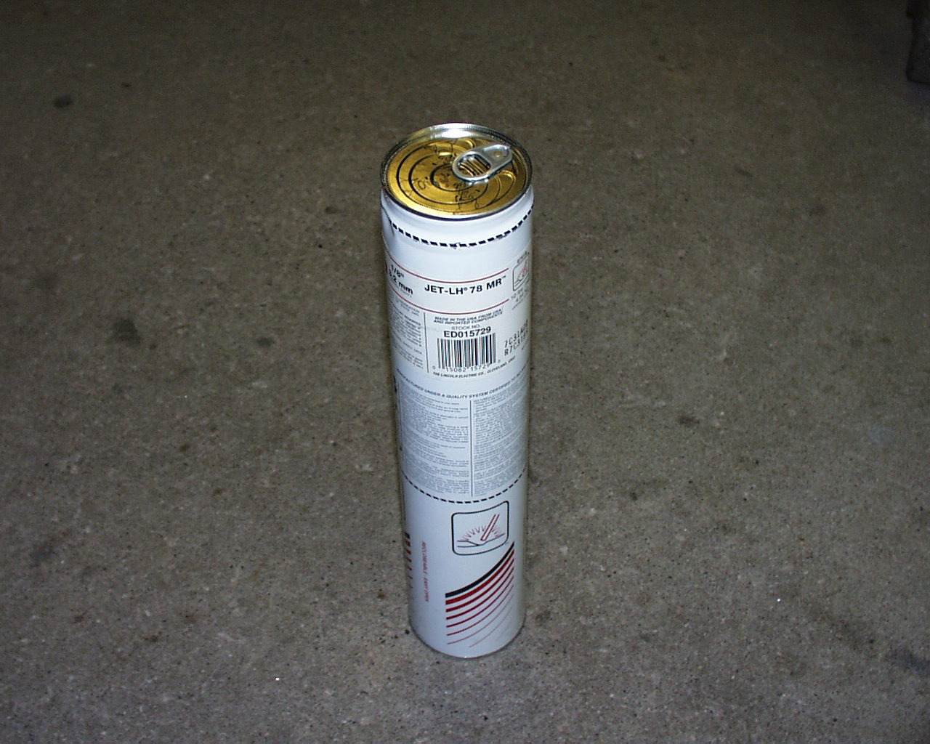
Picture 9

Welding electrodes shall be purchased in hermetically sealed containers. (pic. 9) After the container is opened the electrodes shall be used within 4 hours unless they have been stored in a oven at 250˚ F. After electrodes have been exposed for 4 hours, they shall be dried in an oven for at least two hours between 450˚ F and 500˚ F. Electrodes should be purchased in small packages, allowing for use within the prescribed time limit, unless provisions for an oven are made.

If reviewing the contract documents and communication with the welder is not effective, decertification of the welder may be pursued.

