
Iowa Airport Land Use Guidebook

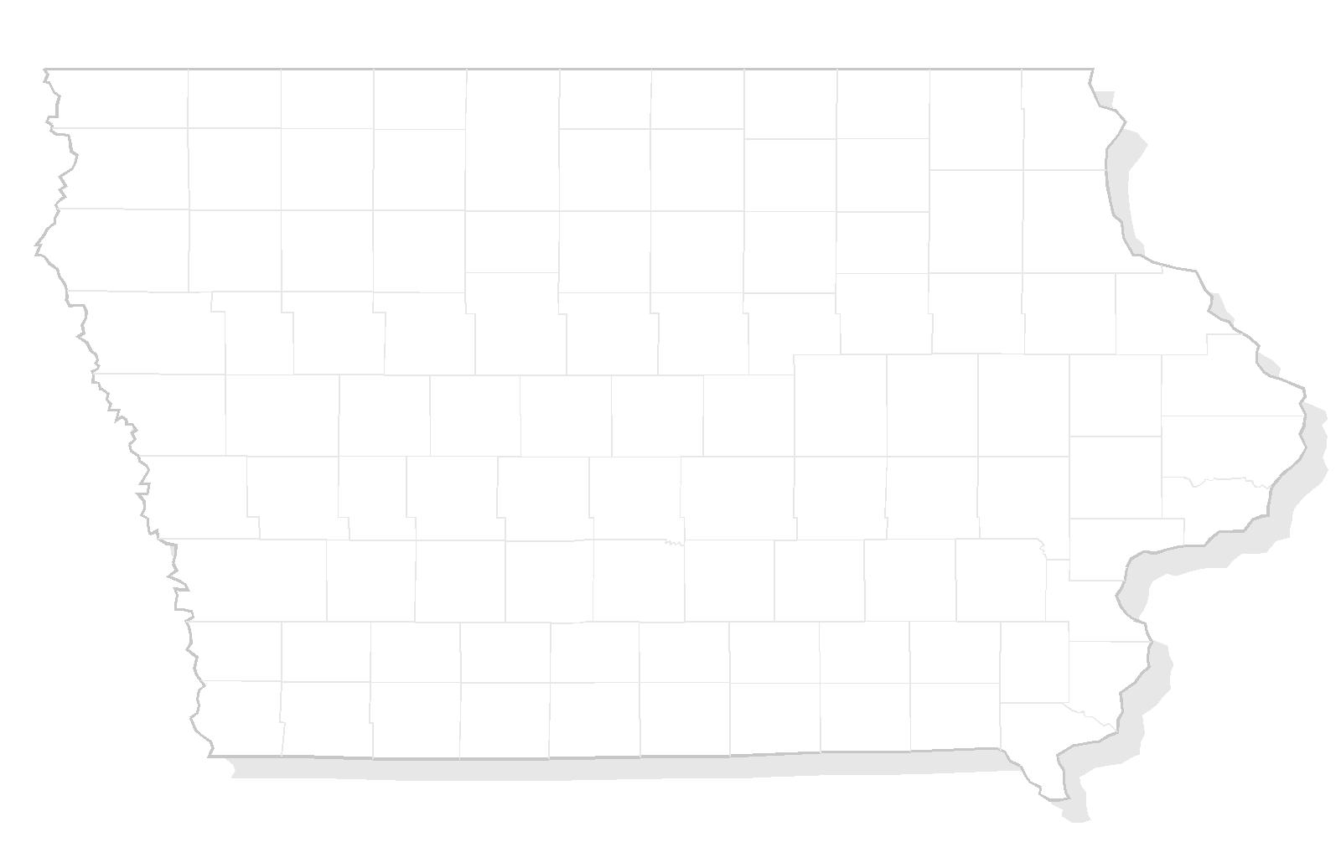

APPENDIX G
AVIGATION EASEMENTS

THIS PAGE INTENTIONALLY LEFT BLANK

Sample – Avigation Easement (For Easements Outside Runway Protection Zone)

THIS INDENTURE is made this day of , 20 between ,
whose address is , , Iowa (“GRANTOR”);
and , whose
address is , , Iowa (“GRANTEE”).

WHEREAS, the GRANTEE is the owner and operator of the Airport
(“AIRPORT”), situated in County, Iowa, and in close proximity to the GRANTOR’s property, as described below, and the GRANTEE desires to obtain and preserve for the use and benefit of the public a right of free and unobstructed flight for aircraft landing upon, taking off from, or maneuvering about the AIRPORT.

NOW THEREFORE, for and in consideration of the sum of $ dollars
($ ) and other good and valuable consideration, the receipt and sufficiency of which is acknowledged, the GRANTOR grants, bargains, sells and conveys to the GRANTEE, its successors and assigns, for the benefit of the general public at large, an easement and right-of-way for the free, unobstructed passage of aircraft, by whomsoever owned or operated, in and through the air space over and across those parts of the GRANTOR's land containing
acres of land within the boundary described as follows:

(See Property Description)

provided, however, that the air space in which that easement and right-of-way is granted shall be that which lies above the heights described and depicted on the attached Exhibit X, which is incorporated by reference.

The GRANTEE and its successors and assigns are to have and to hold that easement and all rights appertaining to it until the AIRPORT is abandoned and no longer used for airport purposes.

In furtherance of this easement and right-of-way, the GRANTOR, for the consideration recited above, grants and conveys to the GRANTEE, its successors and assigns:

(a) a continuing right to keep the air space above the heights described and depicted on Exhibit X clear and free from any and all fences, crops, trees, poles, buildings, and other obstructions of any kind or nature which now extend, or which may at any time in the future extend, above those heights;

(b) a continuing right, at the GRANTEE’s option, to remove to ground level any or all natural growths which extend on the above property above the heights described and depicted on the attached Exhibit X to extent such action is needed. The GRANTEE may determine such action is needed because the GRANTEE in the GRANTEE’S sole discretion finds (i) trimming is unsafe or not reasonably possible, (ii) the species of the tree or other natural growth is too fast growing, or (iii) trimming would have a reasonable probability of killing the tree or other natural growth or causing it to be too susceptible to disease;

(c) The GRANTEE shall have the right of ingress to, egress from, and passage over the GRANTOR’s land described above for the purpose of removing obstructions. Except in cases of imminent danger to health, safety, or welfare, the GRANTEE shall provide the property owner at least 20 days advance written notice of its use this right.

In addition, for the consideration recited above, the GRANTOR covenants, both on the GRANTOR’s own behalf and on behalf of the GRANTOR’s heirs, executors, administrators and assigns, for and during the life of this easement, as follows:

(1) The GRANTOR shall not construct nor permit nor suffer to remain upon the GRANTOR’s land any present or future obstruction that extends above the heights described and depicted on the attached Exhibit X. Provided, however, that any removal or trimming of trees or other natural growth on the GRANTOR’s land as described above which extends above the heights set forth in the Exhibit X shall be conducted by the GRANTEE or the GRANTEE’s agents and at no cost to the GRANTOR.

(2) The GRANTOR shall not use nor permit nor suffer use of the GRANTOR’s land described above in such a manner as to create electrical interference with radio communication between the installation upon the AIRPORT and aircraft or as to make it difficult for fliers to distinguish between airport lights and others, or as to result in glare in the eyes of fliers using the AIRPORT, or as to impair visibility in the vicinity of the AIRPORT, or as otherwise to endanger the landing, taking-off or maneuvering of aircraft; and

Initial
Initial

AVIGATION EASEMENT (outside RPZ)

(3) There is reserved to the GRANTEE, its successors and assigns for the use and the right to cause in said air space such noise, vibration, fumes, dust, and fuel particulates, as may be inherent in the operation of aircraft, now known or hereafter used for navigation of or flight in air, using said air space for landing at, taking off from, or operating on the AIRPORT;

(4) The GRANTOR shall not use nor permit, nor suffer use of the GRANTOR’s land described above for land fills, open dumps, waste disposal sites, etc., storm water retention ponds, creation of new wetlands, crops that would attract or sustain hazard bird movements, or any use that would be incompatible with the maintenance and operation of the AIRPORT.

These covenants shall run with the GRANTOR’s land described above, for the benefit of the GRANTEE and its successors and assigns in the ownership and operation of the AIRPORT.

SIGNED THIS _______ DAY OF ___________________, 20__:

PRINTED NAME SIGNATURE

(L.S.)

(L.S.)

STATE OF IOWA }
COUNTY OF } ss.

On this day of , 20 , before me, a Notary Public, in and for said County, personally appeared to me known to be the same person(s) described in, and who executed the within instrument, who acknowledged the same to be free act and deed.

Notary Public, County, Iowa,

My Commission Expires:

Parcel No.:
Name:
Project No.:
AVIGATION EASEMENT (outside RPZ)
Property Tax Code: | Parcel No.:

PROPERTY DESCRIPTION:

Insert EXHIBIT X Avigation Easement (outside RPZ) here

Sample – Avigation Easement (For Easements in Runway Protection Zone)

THIS INDENTURE is made this day of , 20 between ,
whose address is , , Iowa (“GRANTOR”);
and , whose
address is , , Iowa (“GRANTEE”).

WHEREAS, the GRANTEE is the owner and operator of the Airport (“AIRPORT”), situated in County, Iowa, and in close proximity to the GRANTOR’s property, as described below, and the GRANTEE desires to obtain and preserve for the use and benefit of the public a right of free and unobstructed flight for aircraft landing upon, taking off from, or maneuvering about the AIRPORT.

NOW THEREFORE, for and in consideration of the sum of $ dollars ($ ) and other good and valuable consideration, the receipt and sufficiency of which is acknowledged, the GRANTOR grants, bargains, sells and conveys to the GRANTEE, its successors and assigns, for the benefit of the general public at large, an easement and right-of-way for the free, unobstructed passage of aircraft, by whomsoever owned or operated, in and through the air space over and across those parts of the GRANTOR's land containing
acres of land within the boundary described as follows:

(See Property Description)

provided, however, that the air space in which that easement and right-of-way is granted shall be that which lies above the heights described and depicted on the attached Exhibit X, which is incorporated by reference.

The GRANTEE and its successors and assigns are to have and to hold that easement and all rights appertaining to it until the AIRPORT is abandoned and no longer used for airport purposes.

In furtherance of this easement and right-of-way, the GRANTOR, for the consideration recited above, grants and conveys to the GRANTEE, its successors and assigns:

(a) a continuing right to keep the air space above the heights described and depicted on Exhibit X clear and free from any and all fences, crops, trees, poles, buildings, and other obstructions of any kind or nature which now extend, or which may at any time in the future extend, above those heights;
(b) a continuing right, at the GRANTEE’s option, to remove to ground level any or all natural growths which extend on the above property above the heights described and depicted on the attached Exhibit X to extent such action is needed. The GRANTEE may determine such action is needed because the GRANTEE in the GRANTEE’S sole discretion finds (i) trimming is unsafe or not reasonably possible, (ii) the species of the tree or other natural growth is too fast growing, or (iii) trimming would have a reasonable probability of killing the tree or other natural growth or causing it to be too susceptible to disease;

(c) The GRANTEE shall have the right of ingress to, egress from, and passage over the GRANTOR’s land described above for the purpose of removing obstructions. Except in cases of imminent danger to health, safety or welfare, the GRANTEE shall provide the property owner at least 20 days advance written notice of its use this right.

In addition, for the consideration recited above, the GRANTOR covenants, both on the GRANTOR’s own behalf and on behalf of the GRANTOR’s heirs, executors, administrators and assigns, for and during the life of this easement, as follows:

- The GRANTOR shall not construct nor permit nor suffer to remain upon the GRANTOR’s land any present or future obstruction that extends above the heights described and depicted on the attached Exhibit X. Provided, however, that any removal or trimming of trees or other natural growth on the GRANTOR’s land as described above which extends above the heights set forth in the Exhibit X shall be conducted by the GRANTEE or the GRANTEE’s agents and at no cost to the GRANTOR. This easement prohibits any ground structures, natural growth, storage of equipment, vehicles or aircraft, flammable material storage facilities, or activities which encourage the congregation of people or create an incompatible use in the Runway Protection Zone as referenced in paragraph (5) of this easement.

- The GRANTOR shall not use nor permit nor suffer use of the GRANTOR’s land described above in such a manner as to create electrical interference with radio communication between the installation upon the AIRPORT and aircraft or as to make it difficult for fliers to distinguish between airport lights and others, or as to result in glare in the eyes of fliers using the AIRPORT, or as to impair visibility in the vicinity of the AIRPORT, or as otherwise to endanger the landing, taking-off or maneuvering of aircraft.

Initial
____ Initial
AVIGATION EASEMENT (in RPZ)

- There is reserved to the GRANTEE, its successors and assigns for the use and the right to cause in said air space such noise, vibration, fumes, dust, and fuel particulates, as may be inherent in the operation of aircraft, now known or hereafter used for navigation of or flight in air, using said air space for landing at, taking off from, or operating on the AIRPORT;

- The GRANTOR shall not use, nor permit, nor suffer use of the GRANTOR’s land described above for land fills, open dumps, waste disposal sites, etc., storm water retention ponds, creation of new wetlands, crops that would attract or sustain hazard bird movements, or any use that would be incompatible with the maintenance and operation of the AIRPORT.

- The GRANTOR shall not use nor permit construction on the GRANTOR’s land described above, any structure that is a hazard to the general public or air navigation including the construction of new residences, fuel handling and storage facilities, smoke-generating activities, or places of public assembly, such as churches, schools, office buildings, shopping centers, and stadiums.

These covenants shall run with the GRANTOR’s land described above, for the benefit of the GRANTEE and its successors and assigns in the ownership and operation of the AIRPORT.

SIGNED THIS _______ DAY OF ___________________, 20__:

PRINTED NAME SIGNATURE

(L.S.)

(L.S.)

STATE OF IOWA }
COUNTY OF } ss.

On this day of , 20 , before me, a Notary Public, in and for said County, personally appeared to me known to be the same person(s) described in, and who executed the within instrument, who acknowledged the same to be free act and deed.

Notary Public, County, Iowa,

My Commission Expires:

Parcel No.:
Name:
Project No.:

AVIGATION EASEMENT (in RPZ)
Property Tax Code: | Parcel No.:

PROPERTY DESCRIPTION:

Insert EXHIBIT X Avigation Easement (outside RPZ) here

THIS PAGE INTENTIONALLY LEFT BLANK

